**Godavari College Of Engineering, Jalgaon.**

**Subject Name:** PDE **Teacher Name:** Prof.Nilesh Chaudhari Sir.

**Practical No**. : 6 **Date:**

**Class: S**.E **Roll No: 1951711245011**

**Title:**  AutoCAD Software Study.

## **What Does AutoCAD Stand For?**

Those wondering 'what is AutoCAD?' or 'what is AutoCAD drawing?' should know that CAD stands for 'computer-aided design' -- Autodesk created the most popular program. The Autodesk company prides itself on being a 'leader in 3D design, engineering, and entertainment software', per their website. Through their website, AutoCAD and several other software programs are available for free.

AutoCAD is a computer-aided tool that allows many different types of designers to create diverse kinds of drawings and designs. This program helps designers create their designs much more quickly than by hand and offers many quick, easy, and useful features, such as copy and paste.

### What is AutoCAD Used For?

AutoCAD can create any 2D drawing and 3D model or construction that can be drawn by hand. The program also allows the user to group or layer objects, keep objects in a database for future use, and manipulate properties of objects, such as size, shape, and location.

AutoCAD has numerous applications in a wide range of fields. The program can be used for simple projects, such as graphs or presentations, or complex designs, like drawing up the architecture of a building. Some other practical applications may include:

* Interior designs
* Aeronautical designs
* Logos
* Fine art
* Maps
* Greeting cards
* Engineering designs
* Architectural designs

### Who Uses AutoCAD?

As mentioned, AutoCAD has numerous capabilities that can be applied to an array of projects in various fields. Various kinds of designers are most likely to use the program and it is more common in design-centered fields, like architecture and engineering. Here are a few other examples of careers that likely use AutoCAD:

* Interior designers
* Electrical drafters
* Civil drafters
* Mechanical drafters
* Fashion designers
* Graphic designers
* Set designers
* Process drafters

### **Installation Steps of AutoCAD on Windows**

Step 1: **Access Autodesk website**

Use web browsers like Google Chrome, Mozilla Firefox, etc. Then Go to the AutoCAD official website by using this link: [https://www.autodesk.com](https://www.autodesk.com/)

Step 2: **Select Students and Educators from Drop down list of Menu.**

It will give you three options i.e free trials, students and educators and worldwide sites. Here I am selecting students and educators option

Step 3: **Then you will see Get set up for career success with Autodesk tab. From that tab, click on Start now under Download free software option.**

Step 4: **It will give a list of Autodesk products like 3DS Max, Maya, AutoCAD, etc. Under that click on the AutoCAD option from the list.**

Step 5: **If you have already registered then click on Sign in and you will be forwarded to your Autodesk Login information. Otherwise, click on Create Account and create a new account using your email ID.**

Step 6: **Select version**

After signing in, you can select the version of AutoCAD you want to download and install and Operating System: 32 bit or 64 bit

Step 7: License and Services AgreementAfter that, you will see the “License and Services Agreement” Prompt. Read it carefully and then click on the “I Accept” option then click the next button to install AutoCAD on your Windows System.The AutoCAD Download Manager will be displayed. This can take some time.

Step 8: After the installation of the manager, you will see an “Autodesk Download Manager” window. Specify the desired path where you want to save that file and click on OK.

Step 9After that, you will see a window where you can configure the Autocad installation process. Here give the path where you want to save the files.

Step 10: In the next window, select the Custom Option. Make sure all the features under drop-down are checked.

Step 11: Then you will be prompted to the next window. Then click on the Install option.

Step 12: After installing all the products and tools related to AutoCAD, Click on Finish.

Step 13: After finishing the installation, you have to provide Product Key to further the use of AutoCAD.

In case you haven’t copied the Product Key previously, Sign in to AutoDesk account on the website -> Click on your username -> Click on AutoDesk Account.

Step 14:Click on the “All Products and Services” option. This will show the products you have downloaded.

Step 15:Under AutoCAD option, Click on the “More actions” drop-down -> click “Serial numbers”.Now you can see Serial Numbers and the Product Keys of all the products which you have downloaded. Copy this information and activate your Autodesk product.

Now you can use AutoCAD software and design your own models easily.

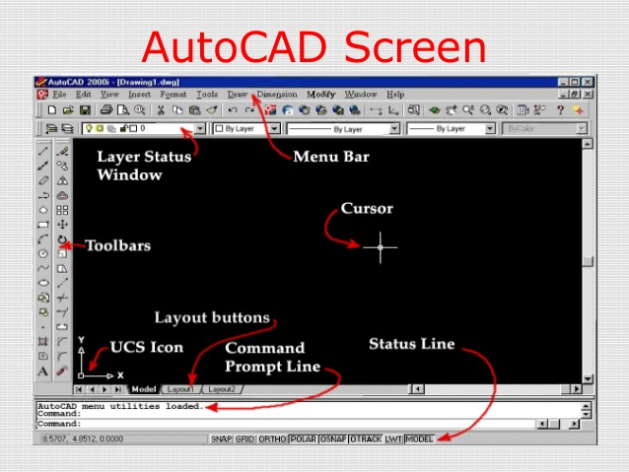

#### **Applications:-**

* Aerospace calls their final design as an assembly.
* Automotive call their final design as Parts design.
* Electrical and electronics call their final design as Blueprint and Circuit design.
* Rail and marine call their final design as Layout or Blueprint.
* Structural and civil call their final design as Layout.

#### **Benefits of AUTOCAD:**

* It has the ability to produce very accurate designs
* Drawings can be created in 2D or 3D and rotated.
* Other computer programmes can be linked to the design software.
* AutoCAD as an architectural planning tool: It enables architects to design, plan, execute and analyze the strength of a building, at design stage level.
* AutoCAD as an engineering drafting tool: It helps engineers to design, analyze and solve design issues resulting in accurate designs.
* In 3D printing: A 3D print has its own advantages for designers and for this software helps them. The designs can be exported to various preferred formats.
* AutoCAD in the fashion industry: It has the tools necessary for planning designs for the manufacture of jewelry, toys and other delicate objects.
* AutoCAD as industrial design tool: It helps to reduce manufacturing costs as it saves time and efforts required for manual designing.

#### 

#### Reasons for implementing CAD systems:

* To increase the productivity of the designer.
* To improve the quality of design.
* To create a database for manufacturing.
* To improve communication through documentation.

**Conclusion:-** In this Assignment i learn what is AutoCAD , how to implement it, and Utilization Of it in Product Design Engineering.( PDE.) AutoCAD is the most widely used computer-aided software for producing architectural drawings. Not only in computers but AutoCAD is available as a mobile app which has a huge demand.